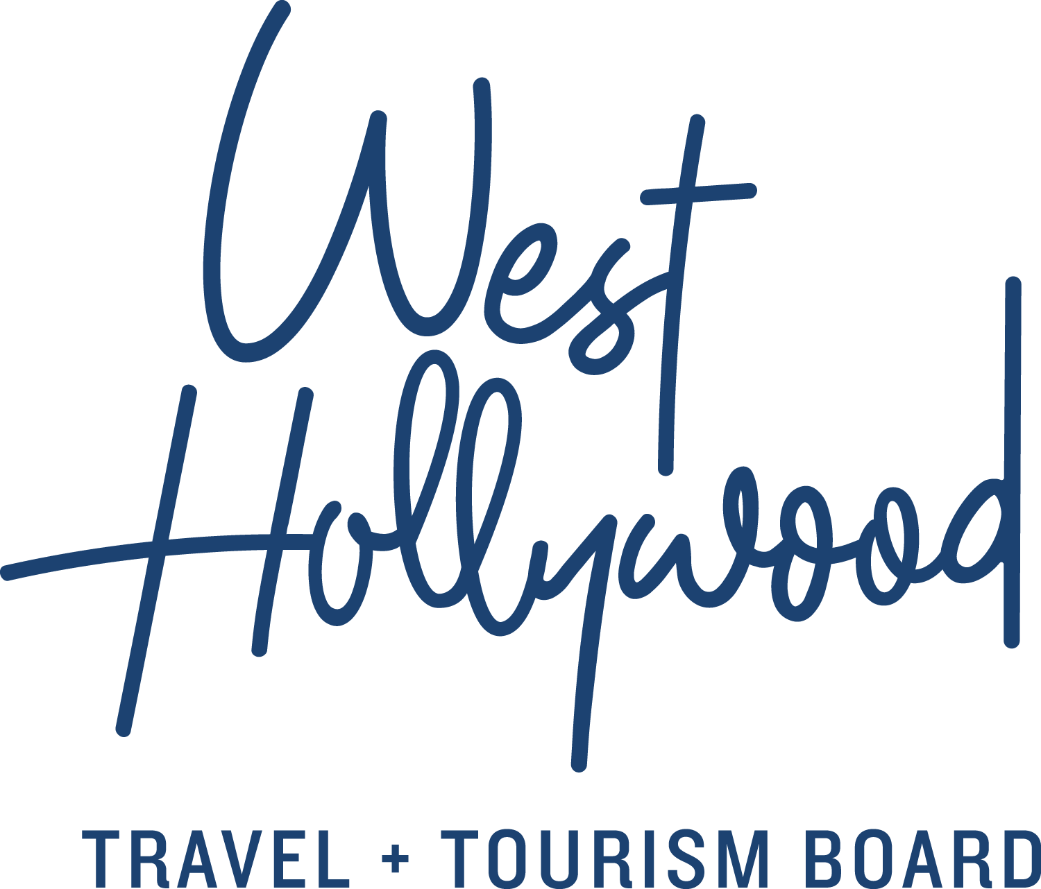

18 Facts about the City of West Hollywood, California — A Snapshot of Our City in 2018

Thirty-four years ago, in 1984, the idea for a City of West Hollywood was proposed by an unlikely coalition of LGBT activists, seniors, and renters. These groups came together to form a City like no other with progressive policies and strong tenants’ rights protections. Through tireless determination, the City of West Hollywood was officially incorporated as an independent City on November 29, 1984; previously, West Hollywood had been an unincorporated section of Los Angeles County. The first West Hollywood City Council established West Hollywood as the first City in the nation to have a majority openly gay governing body.

Over the past almost three and a half decades, the City of West Hollywood has demonstrated that it is like no other city in the world. Located in the heart of metropolitan Los Angeles, at 3 square kilometers, West Hollywood is a robust economic and cultural center instilled with idealism, creativity, and innovation. A spirit of community activism and civic pride thrives in West Hollywood for many of its approximately 35,000 residents.

1. We provide remarkable social services.
Just after the City of West Hollywood was incorporated, it established its Social Services programs to provide much-needed services to residents. Over its history, the City has provided millions of dollars in grants to fund programs for people in need. These include services for seniors; people with HIV and AIDS; members of the LGBT community; people with disabilities; alcohol and drug use recovery programs; support programs for Russian-speaking immigrants; services for people who are homeless; food programs; and health care services for people who are uninsured. City residents live longer and have lower rates of chronic diseases than residents of L.A. County as a whole.

2. We run a tight ship when it comes to fiscal responsibility.
The City of West Hollywood has received high marks for sound general and fiscal management policies. The City, with its diverse revenue base, recovered more quickly from the 2008 recession than most cities in the nation and receives top ratings from agencies such as Standard & Poor’s (S&P). The City also maintains an implied general obligation bond rating of ‘AAA’.

3. We love where we live.
In 2013, the City conducted a Community Study, which was one of the most intensive community engagement projects in the City’s history. The Community Study updated the City’s demographic data and provides information that informs funding priorities for social services initiatives. Ninety percent of respondents rated their quality of life as excellent or good, citing pedestrian orientation, central location, safe and quiet neighborhoods, amenities, and well-kept infrastructure. Did we mention the lovely weather?

4. We want to marry you.
West Hollywood was one of the first cities in the country to pass a resolution in support of marriage equality, paving the way for same-sex marriage initiatives all over the country. In June 2008, in a monumental moment in U.S. history, the city, in conjunction with the Los Angeles County Register-Recorder Clerk, began to issue marriage licenses and perform civil ceremonies for same-sex couples after the California Supreme Court ruled that a ban on same-sex marriage was unconstitutional. The City was forced to halt those marriages in November 2008 with the passage of Proposition 8, a constitutional amendment prohibiting same-sex marriage. A long legal battle ensued in federal court, which finally resulted in the U.S. Supreme Court dismissing an appeal in Hollingsworth v. Perry in June 2013 allowing same-sex marriages to resume. The City of West Hollywood launched a marriage celebration, and to date, West Hollywood councilmembers and city officials have performed thousands of civil ceremonies.

5. We think home is where it all begins.
Not long after the City was incorporated, the West Hollywood City Council adopted its landmark Rent Stabilization Ordinance. Upon its adoption, this was one of the strictest rent control laws in the country. The City has an entire division dedicated to rent stabilization and housing programs that promote a strong and vibrant residential community. The City provides a breadth of information and counseling services to both tenants and owners of residential rental properties, which includes in-house counseling services and written materials. The division also facilitates the development of new housing, the rehabilitation of existing buildings, and the development of mixed-use projects with a housing component.

6. We want you to be healthy.
The onset of the HIV/AIDS epidemic had a significant impact on the City of West Hollywood. The disease’s elevated infection rate among gay men caused a devastatingly high number of deaths in the City. The City of West Hollywood was one of the first government entities to provide social services grants to local AIDS and HIV organizations. The City sponsored one of the first AIDS awareness campaigns in the country in October 1985 and the City’s response to the AIDS crisis has been recognized as a model for other cities, nationally and globally. The City has recently announced a vision to become a “HIV Zero Transmission” City by 2020.

7. We act locally. We think globally.
During its three decades, the City of West Hollywood has become one of the most influential small cities in the nation. We blaze a trail on progressive policy issues. No other city of its size has had a greater impact on the national progressive public policy agenda and our media reach is international. When there is injustice, we speak out. Ranging from LGBT rights, the city’s Rent Stabilization Ordinance to the many Social Services it provides, the city has demonstrated that it is like no other city in the world. A strong spirit of community activism and civic pride thrives in the City and people from all over the globe visit to experience it.

8. We’re here. Some of us are queer. We’re used to it.
The City of West Hollywood has been one of the most outspoken advocates for the legal rights of LGBT people. In 1985, the City of West Hollywood was one of the first cities in the country to adopt a Domestic Partnership Ordinance. A month shy of the 30 year anniversary of cityhood, West Hollywood marked an exciting milestone as the City Clerk’s office at West Hollywood City Hall filed its 10,000th couple as registered Domestic Partners in October 2014. The City also created the nation’s first municipal Transgender Task Force in 2001; in 2009 this became the City’s Transgender Advisory Board. Today’s openly gay Councilmembers still receive international attention for being out and proud as elected officials.

9. We believe in women.
The City of West Hollywood supports women and fights for equal rights. The City, in 1993, was the first city in the nation to declare itself pro-choice and it has continually supported state and federal legislation protecting and advancing women’s reproductive rights and access to healthcare. The City has a strong record of supporting initiatives that call for equal pay for equal work. The City also has a Women’s Advisory Board, which is involved in a myriad of programming and events that recognize and support women in the community. The two most recently elected Councilmembers in West Hollywood are both women.

10. We walk the walk.
The City of West Hollywood has been voted The Most Walkable City in California with a score of 91/100 by Walk Score, a service that helps promote walkable neighborhoods across the country. According to Walk Score, ranking rates are based on the distance to nearby amenities, such as grocery stores, restaurants, shopping, banks, schools, parks and public transit. West Hollywood’s walkability is ranked higher than San Francisco, Los Angeles, and San Diego. The City encourages a fitness walking route with its Well West Hollywood walking routes, which connect West Hollywood Park and Plummer Park — a brisk round-trip walk on this route is equal to five miles or 10,000 steps, which is common benchmark cited for a health, exercise, and weight management routine. Throughout the years, West Hollywood’s pedestrian-friendly policies have included improving pedestrian connections to city parks, increased green-space and encouraging the location of neighborhood-serving businesses and amenities within walking distance of all residential neighborhoods in order to encourage walking as a desirable mode of transportation.

11. Мы говорим по-русски. (We speak Russian).
The City of West Hollywood is home to a thriving community of people from regions of the former Soviet Union who fled anti-Semitism— between the 1970s and the 1990s—or came to the region during the breakup of the Soviet Union in the late 1980s. According to a recent survey of the community in West Hollywood, there are nearly 4,000 people who live in the City who identify a former country of the Soviet Union as their primary ancestry, representing approximately 11 percent of the City’s total population. All city materials are provided in both Russian and English.

12. We love animals. We work to protect them.
The City of West Hollywood has been on the forefront of the animal rights movement for decades and the City’s commitment to animal rights is one of its legacies. The City has consistently worked to enact leading-edge animal welfare legislation. Legislation was enacted for pet owners to be classified as pet guardians, and declawing of cats were outlawed in 2003. The City’s fur-ban ordinance, which went into effect in 2013, is one of the first of its kind in the United States. All retail establishments located within the City of West Hollywood are prohibited from selling, trading, distributing, importing or exporting any fur product. The term “fur product” means any item of personal attire, clothing or garment, which is composed in whole or in part from the pelt or skin of any animal with its hair, fleece (wool) or fur attached. The ban applies to shearing products, as the skin for such products is tanned with the wool still attached.

13. We’re artsy.
The City of West Hollywood has a love affair with arts and culture. From walkable urban collections such as West Hollywood Library’s murals showcasing Shepard Fairey’s largest installation to iconic design institutions like the Pacific Design Center and the MAK Center for Art and Architecture, West Hollywood is a cultural destination to be explored inside and out. The city’s thriving creative and entertainment communities set trends in design, dining, music, fashion, art, and architecture.

14. We’re a young city. Yet more than a few of us are seniors.
The City of West Hollywood is home to a large number of seniors. Approximately 15 percent of the City’s population is senior, compared with 11 percent in Los Angeles County. The City has a long history of providing services and programs for seniors. In a 2013 survey of the community in West Hollywood, 86 percent of seniors reported that their quality of life is excellent or good. The City is developing an Aging in Place initiative, which will provide clear goals for the City’s work in anticipating and preventing obstacles to older adults who choose to remain in their West Hollywood homes. This will build on existing policies and programs, such as senior services, arts and cultural events, and approaches to wellness, and provide an integrated path for encouraging a supportive and compassionate community.

15. We PickUp.
The City launched The PickUp Line in 2013 — a complimentary trolley service that’s a cool and convenient alternative to driving for people who go out to nightlife and dining spots on or near Santa Monica Boulevard on Friday and Saturday (8pm-3am) and ‘Sunday Funday’ (2pm-10pm). The PickUp is fun, flirtatious, and irreverent. The trolley uses a bright palette of black, white, yellow, and red — its graphics looks like 1960s pop art. Local DJ Derek Monteiro mixes up a full night of tracks for an on-board music experience. The best part is that riders can leave the car at home and everyone benefits from less driving under the influence.

16. We throw great parties.
Each June, West Hollywood is the epicenter of regional LGBT pride festivities. In addition to the annual Christopher Street West LA PRIDE Celebration and Parade, the City celebrates the artistic contributions of the LGBTQ community with its vibrant and eclectic One City One Pride arts festival, which features exciting arts, culture, and community events ranging from exhibits to author talks to music performances to stage productions. Every October, the City hosts one of the most unique Halloween gatherings in the world, Halloween Carnaval.

17. We’re always looking toward the future.
The City of West Hollywood has invested in a series of leading-edge Capital Projects, including an amazing Master Plan for West Hollywood Park. In 2011, the City celebrated the opening of its new LEED-rated West Hollywood Library to showcase the City’s rich intellectual, literary, and cultural diversity. The City is passionate about adopting fresh new ideas and the latest in technological advancement. At West Hollywood City Hall, staff members have formed an Innovation Catalyst Group (ICG), which explores the development and implementation of groundbreaking ideas. The City, through this group, has laid the groundwork for exciting new resources such as a Geographic Information Systems (GIS) initiative, an Open Data initiative, a new web-based platform for civic engagement, and a West Hollywood Smart City Strategic Plan to incorporate smart technologies into the urban infrastructure.

18. We want you to sleepover.
West Hollywood currently has 19 establishments for lodging, ranging from vintage bungalows and motels, lovely all-suite hotels in quiet neighborhoods, comfy and assuring brand hotels and boutique chic hotels full of pampering and poolside pleasures. New hotel product in 2018 increased the city’s inventory by almost 20%, including the much-anticipated Jeremy West Hollywood and La Peer Hotel.

About West Hollywood Travel + Tourism Board
West Hollywood Travel + Tourism Board is the official marketing organization that invites visitors to West Hollywood, California, a walkable, 1.9 square mile/4.9 square kilometer city in the heart of Los Angeles. Located at the base of the Hollywood Hills and adjacent to Beverly Hills, West Hollywood is a creative and progressive city that embodies the quintessential L.A. lifestyle. West Hollywood is home to 17 hotels and comprised of three main districts: the world-famous Sunset Strip with unparalleled nightlife, eclectic and LGBTQ-friendly Santa Monica Boulevard, and the Design District known for its sought-after shopping and dining. West Hollywood enjoys a year-round moderate climate and thanks to its prime location and hip atmosphere, West Hollywood serves as home and playground to many celebrities. Follow us on Facebook & Twitter (@westhollywood) and Instagram (@visitweho). www.visitwesthollywood.com
##
Press Contact:
Anne Van Gorp, media@visitwesthollywood.com

