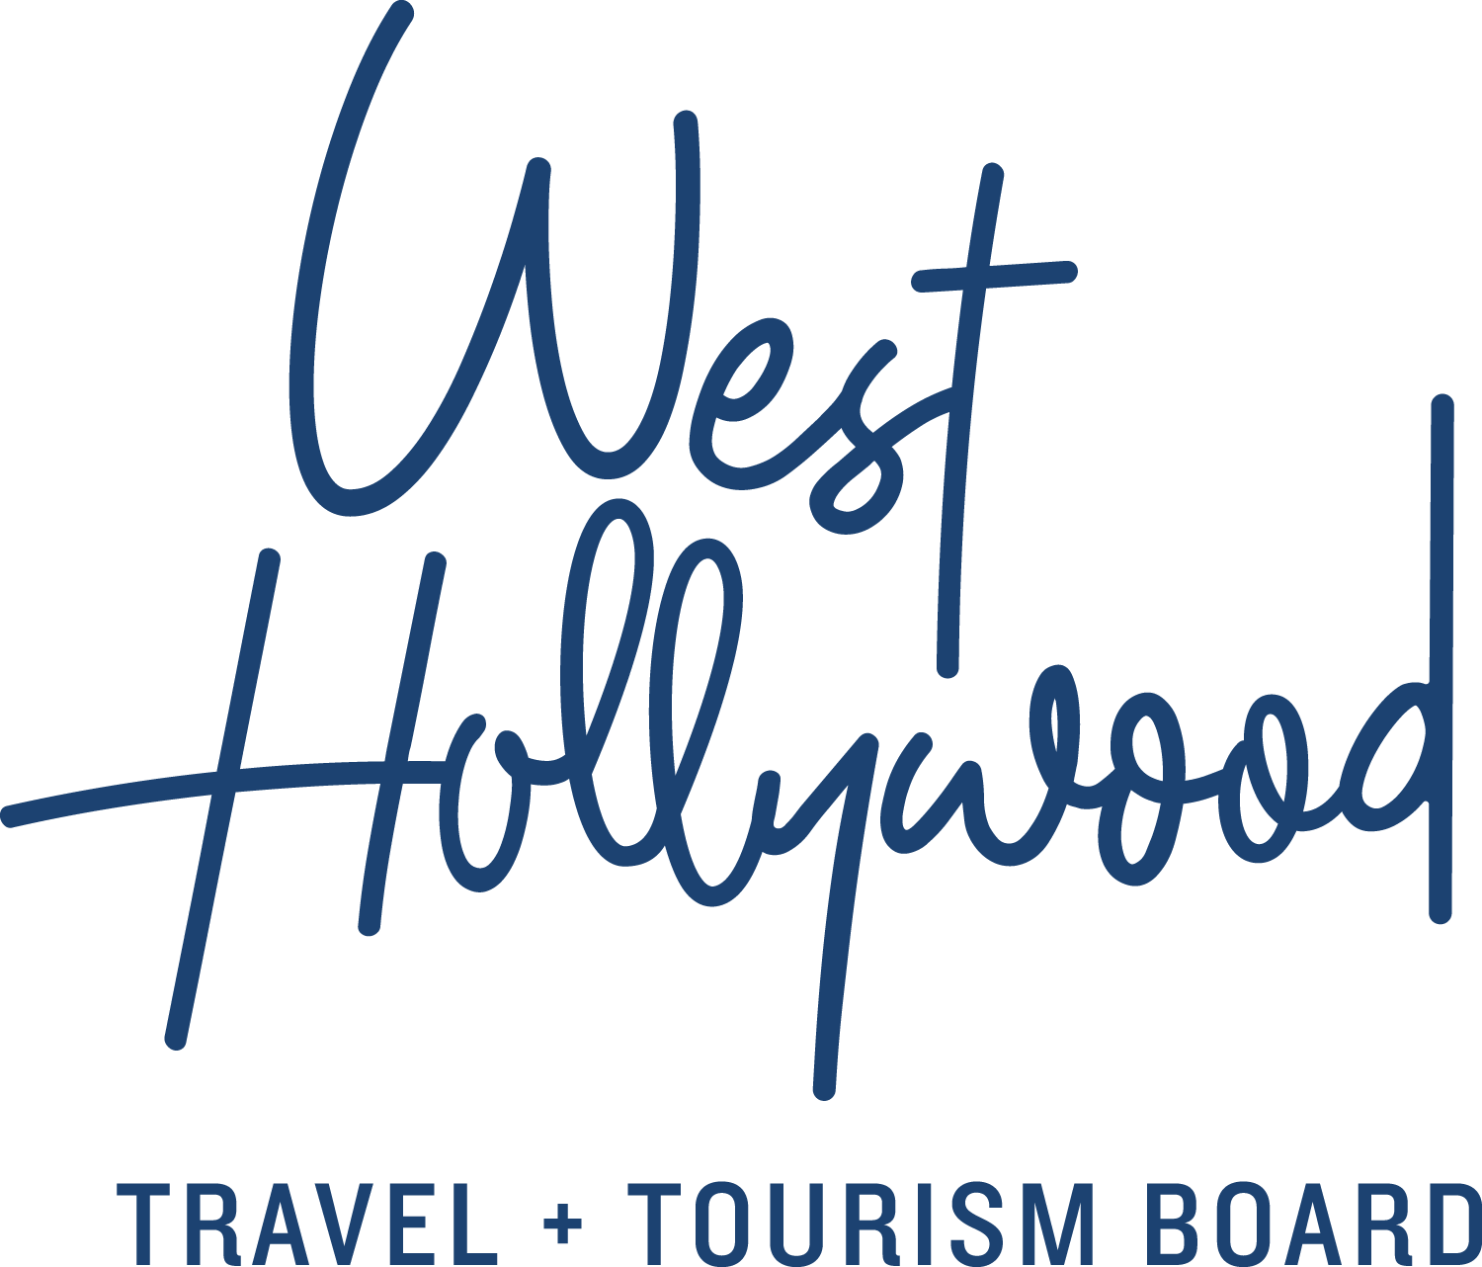
5 Myth Busters about West Hollywood, California that Could Move You to Visit
West Hollywood, California, or WeHo as it’s known to locals, is a tiny town with a big reputation of all things it is not. It’s not Hollywood (a neighborhood of Los Angeles), a Manhattan neighborhood (that’s SoHo), or simply a movie set (although The Lot, originally owned by Douglas Fairbanks and Mary Pickford still operates here and is home to OWN, the Oprah Winfrey Network). It’s not just for celebrities and paparazzi, or for anyone famous enough to score a restaurant reservation on Friday at 8 p.m. (But if you can, we would love to be introduced.) Above all else, it’s not judgmental: everyone is welcome. To set the record straight, here are some common myths debunked about the cool town of West Hollywood, California, and why it should be on everyone’s travel bucket list.
- It’s La La Land or Tinseltown
West Hollywood, commonly mistaken for a neighborhood in Los Angeles, is its own city. This tiny enclave of 1.9 square miles/4.9 square kilometers is tucked between its tony neighbors of Beverly Hills and the Hollywood district of Los Angeles.
Just as towns were created for protection, a sense of community, and law and order during America’s early years, so was West Hollywood. It incorporated in 1984 to focus on its critical mission: to administer social services and create strong policies and protection for its residents, an unorthodox extended family of Russian immigrants, LGBTQ activists, renters and seniors.
Famous icons include the Sunset Strip, Pacific Design Center, and restaurants and nightclubs where celebrities go in, go out, and get photographed. Los Angeles International Airport (LAX) and Burbank Bob Hope Airport (BUR) connect visitors via domestic and international flights, 12 miles/19 kilometers and 11 miles/18 kilometers away from West Hollywood, respectively.
Staying in West Hollywood gives visitors a central address from which to explore all the great things to see and do in nearby cities and neighborhoods.
- It’s just for the Boys, and on the beach
It’s not. Boystown, which isn’t a town but a sense of place, proudly exists in West Hollywood. While 40% of our residents fall under the LGBTQ alphabet, and West Hollywood is home to The Abbey, one of the most popular gay nightclubs in the U.S., it is a welcoming city for anyone to be who they are. Two annual events, LA Pride in June and Halloween Carnaval in October, showcase the city’s diversity and make for a good time.
That famous summer gloom? Not in West Hollywood. We sit just inland enough to sidestep beach fog. For visitors to West Hollywood, Instagrammable pools deliver on every count – weather, posh comforts and lounge chair delivery of every imaginable culinary delight. West Hollywood has more rooftop pools per square mile than anywhere we’ve ever been. It rises above it all and still affords beach views.
- It’s pricey
Although most amazing places worth precious vacation time can be a budgetary stretch, ask yourself if the stretch is worth it. Consider this: West Hollywood’s tiny footprint, navigable even in designer heels, by definition means that everything is walkable (or at least a quick Uber away). West Hollywood Travel + Tourism Board’s website displays hotel locations, rates, events and activities nearby – so you can stay where you play and avoid unnecessary transportation. For better hotel rates, book slightly off-season dates. Hotels often offer deals and food credits for suites, so bring a friend or two and share the cost.
Since some of West Hollywood’s best hotels were once lavish apartments, this can mean staying on a quiet, tree-lined street in a huge suite – complete with a kitchen, private club bar and eatery, stunning rooftop pool, expert concierge assistance and daily room attention. New hotels are on the horizon, meaning more rooms for everyone, while West Hollywood’s cool vintage motels deliver the goods without a commensurately big price tag.
- You have to be rich and gorgeous to fit in
Not so, although it’s easy to believe when thumbing through celeb-stalking tabloids. “There are all shapes, sizes, ages and types living here and visiting,” says Danny Roman, owner of Bikes and Hikes LA, a West Hollywood-based outdoor adventure company rated No.1 in Los Angeles on TripAdvisor. West Hollywood residents remain vibrant with plenty of sunshine and healthy options, which appeals to visitors of all ages from cloudy, dreary cold weather regions. (Easy for Danny to say: he fits the gorgeous category and brings fresh cold-pressed juice to meetings.)
- You have to have a car here
In L.A. you might, because it has freeways, it’s big, and all the cool places are spread out. Not so in West Hollywood. Walk Score, which ranks from one to 100 the walkability of any address, gives West Hollywood a 91; that’s an “A+” on our curve. There are also great alternatives to walking. West Hollywood is on the Red Route of Starline Tours’ Hop-On Hop-Off CitySightseeing double decker buses, whose four routes and two shuttles connect one hundred miles, the world’s largest Hop-On Hop-Off route. West Hollywood’s cheap and cheerful bike rental program, WeHo Pedals, is available throughout the city and is part of Bike Share Connect which merges with the bike share programs of Beverly Hills, Century City, West LA and Santa Monica. The PickUp and Sunset Trip invite bar hoppers to jump aboard for free trolley rides during busy weekend nights on Santa Monica Boulevard and Sunset Boulevard, respectively, with The PickUp offering a Sunday Funday ride on Sundays from 2 p.m. to 10 p.m. If you do have a car, park it at your hotel or the city’s robotic parking garage.
While “going to Cali, Cali” is more well-known than “we go to WeHo, WeHo”, and nothing matches the magnetic connectivity of Los Angeles, for a heightened reality trip to California, explore the destination of West Hollywood at www.visitwesthollywood.com.
About West Hollywood Travel + Tourism Board
West Hollywood Travel + Tourism Board is the official marketing organization that invites visitors to West Hollywood, California, a walkable, 1.9 square mile/4.9 square kilometer city in the heart of Los Angeles. Located at the base of the Hollywood Hills and adjacent to Beverly Hills, West Hollywood is a creative and progressive city that embodies the quintessential L.A. lifestyle. West Hollywood is home to 17 hotels and comprised of three main districts: the world-famous Sunset Strip with unparalleled nightlife, eclectic and LGBTQ-friendly Santa Monica Boulevard, and the Design District known for its sought-after shopping and dining. West Hollywood enjoys a year-round moderate climate and thanks to its prime location and hip atmosphere, West Hollywood serves as home and playground to many celebrities. Follow us on Facebook & Twitter (@westhollywood) and Instagram (@visitweho). www.visitwesthollywood.com
##
Press Contact:
Anne Van Gorp, media@visitwesthollywood.com

