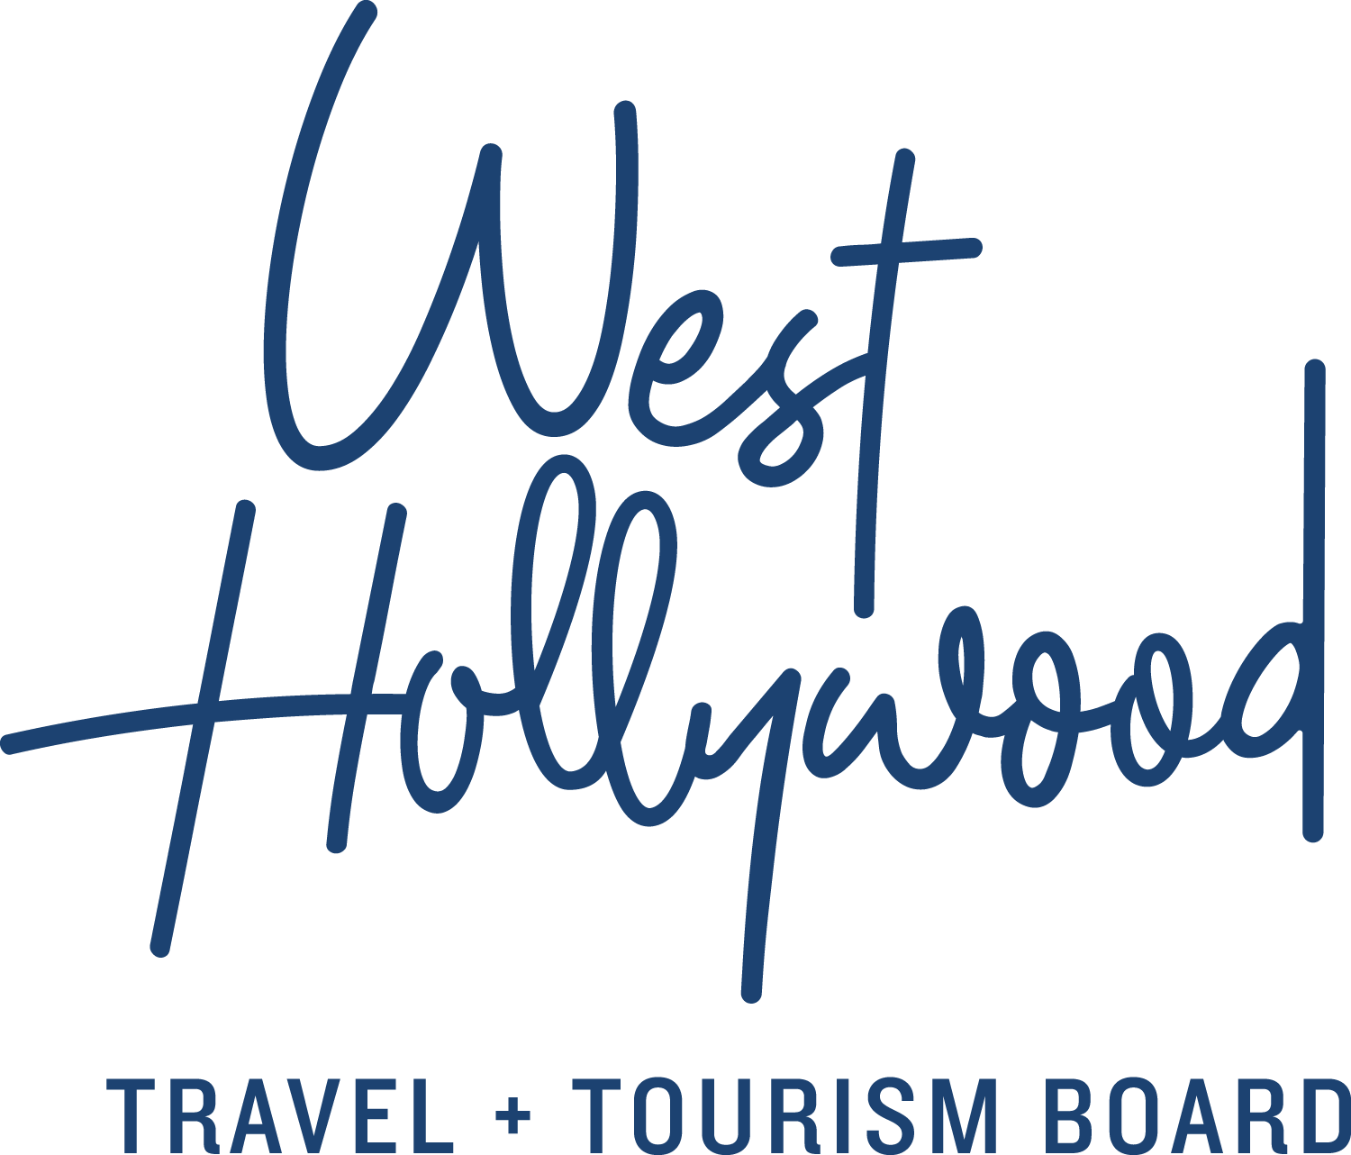
West Hollywood, California’s go-to-guide to the City’s Three Districts
The Sunset Strip
After decades of notoriety, the Sunset Strip continues to blaze its own path as a world-famous cultural landmark, setting trends in music, hotels, dining and shopping. This most famous stretch of Sunset Boulevard begins and ends in West Hollywood, and like the city it calls home, it is constantly breaking new ground and reinventing itself.
Though it’s often been portrayed in movies like Sunset Boulevard, Almost Famous and Rock of Ages, visitors say that nothing compares to seeing the Sunset Strip up close and in person. Bordered on the west by Beverly Hills and on the east by Hollywood, this iconic stretch of Sunset Boulevard features an array of world-class hotels, nightclubs, restaurants, shops and spas.
Through the years, the Sunset Strip has seen it all, starting with the seedy glitz of the 1920s, when Prohibition fueled the rise of nightclubs and speakeasies. Because West Hollywood was not yet an incorporated city, this strip of Sunset Boulevard was lightly policed, making the Strip the perfect playground for the rebellious denizens of early Hollywood. By the 1940s, swanky nightclubs like Ciro’s, Trocadero and Mocambo reigned supreme, attracting A-list celebrity clientele like Marilyn Monroe along with less savory characters like gangster Bugsy Siegel, who called the Strip his stomping grounds.
In the 1960s, the Sunset Strip became the major gathering place for the counterculture movement in Los Angeles. Janis Joplin, Jimi Hendrix and Jim Morrison were fixtures of the Strip and the surrounding West Hollywood landscape. The Whisky a Go Go introduced go-go dancers to the U.S. and propelled The Doors—who at the time were the club’s house band—to fame and notoriety. The Strip continued to be a major focal point for the punk rock and new wave scenes during the late 1970s, and it also became ground zero for the colorful glam metal scene, hosting bands like Mötley Crüe, Guns N’ Roses and Poison throughout the 1980s.
The Sunset Strip continues to launch new artists and attract crowds to legendary music venues like The Roxy Theatre, Whisky a Go Go and The Viper Room. Meanwhile, swank hotel bars such as Tower Bar at the Sunset Tower Hotel and Skybar at Mondrian LA boast some of the most popular and exclusive hideaways on the Strip.
The Strip isn’t all nightlife though; daytime visitors will enjoy the high-end shopping and al fresco dining of Sunset Plaza, one of the hottest places to “see and be seen” in Los Angeles. Experience the area entirely on foot, taking in the fabulous Southern California sunshine and spectacular city views. See why visitors are drawn from around the world to this eclectic destination.
Did you know?
- In 2012 a documentary titled Sunset Strip was released, featuring interviews with stars like Keanu Reeves, Johnny Depp, Mickey Rourke, Dan Aykroyd, Hugh Hefner, Sharon Stone and many more.
- The Sunset Tower Hotel was once an apartment building that old Hollywood stars like Marilyn Monroe, Bugsy Siegel, Frank Sinatra and John Wayne (who kept his cow on his balcony) called home.
- The Las Vegas Strip was named after the Sunset Strip.
- Sunset Strip boasts tall billboards that are second only to Times Square in size and cost.
Santa Monica Boulevard
West Hollywood has never been known for following trends. It’s known for setting them, and nowhere else is this more apparent than on Santa Monica Boulevard.
This eclectic thoroughfare, which was once an industrial strip of road dotted with film studios as well as the Los Angeles Pacific Railway, connects the east side of Los Angeles with the Pacific Ocean, passing through Hollywood, West Hollywood, Beverly Hills, Century City, West LA and ending in Santa Monica. And while this street goes through various personas as you head in either direction, nowhere is Route 66 more diverse, fun or pedestrian-friendly than the 1.9 mi/3.05 km stretch that runs through West Hollywood.
Route 66 was America’s main road in the 1950s for travelers heading west, and today, you can still see signage for Route 66. West Hollywood’s portion of “The Boulevard” runs from La Brea Avenue on the east to Doheny Drive on the west. On Santa Monica Boulevard’s eastern side, visitors can check out local favorite bars and restaurants such as Laurel Hardware, Now Boarding, The Hudson, Harlowe Bar and the James Beard Award-nominated “seafood shack” Connie and Ted’s.
Heading west, you arrive in the heart of West Hollywood and discover unique celebrity-frequented restaurants, eclectic boutiques, coffee shops, gyms and bookstores. With the rainbow flags along The Boulevard, this area is where you see firsthand the guiding principle on which West Hollywood was built: the freedom to be yourself and to live life your own way. Santa Monica Boulevard is home to the most popular gay and lesbian scene in Los Angeles, with popular gay nightclubs like The Abbey, Flaming Saddles, Micky’s, Fiesta Cantina and Revolver. From upscale to laid-back, anyone fits in when you’re experiencing Santa Monica Boulevard in West Hollywood.
Did you know?
- Walk Score, a company that maintains a public-access walkability index of any place in the United States, Canada and Australia, has named West Hollywood the “Most Walkable City in California” with a score of 91.
- The Pride Parade on Santa Monica Boulevard is the second-largest event in Los Angeles County, second only to the Rose Parade.
- The city approved permanent rainbow crosswalks. Installed in 2012, the crosswalks, painted in the rainbow colors of the LGBT flag, represent gay pride and LGBT rights and can be viewed on Google Earth
- The beginnings of Hollywood can be traced back to the United Artists movie studio in the 1930s on Formosa Avenue and Santa Monica Boulevard. Today, this studio is known as The Lot and is home to Oprah Winfrey’s OWN television empire.
- The Historic club the Troubador on Santa Monica Boulevard, played host to Elton John’s first U.S. concert and continues to house both indie bands and bigger acts like Coldplay and The Cure.
West Hollywood Design District
Experience the West Hollywood Design District, the heart of high-caliber design, fashion, art, dining, beauty and more. Located at the intersections of Melrose Avenue, Beverly Boulevard and Robertson Boulevard, the West Hollywood Design District offers a distinct mix of global designer flagships, local boutiques, art galleries, interior design showrooms and chic eateries. This walkable district is an unrivaled international destination for design savvy professionals and sophisticated shoppers alike.
Back in the 1950s, the neighborhood held only a handful of shops, studios and cafés catering to the design trade, and Ed’s Coffee Shop was the place to meet fellow designers over a toasted ham sandwich and a cup of joe. Later, in the 1960s, businesses like Phyllis Morris Originals became “designers to the stars” and brought more and more style-seekers into the area, slowly transforming it into one of the most distinguished design districts in the country. As more design trade resources opened their doors, the influx of artists, dressmakers, upholsterers, dancers and musicians fleshed out the bohemian spirit of the burgeoning design district.
Home to more than 200 of the world’s finest art galleries, furniture designers, fashion boutiques, salons and spas, alfresco cafés and fine restaurants, West Hollywood Design District is known worldwide for its impeccable selection of luxury products, services and experiences for those seeking the very best. Trends start here, with a unique mix of world-renowned fashion retailers including Christian Louboutin, Moschino and Stella McCartney, and a mix of local favorites including H. Lorenzo (H-L-N-R), Jenni Kayne, The Elder Statesman and Maxfield.
The West Hollywood Design District offers both the professional and amateur designer a wealth of high-design inspiration. Interior design showrooms such as Christopher Guy, Dennis & Leen, Design Within Reach, J. Robert Scott, Rose Tarlow Melrose House, and RH West Hollywood emphasize the impact of the district on the design world. Art galleries including M+B Gallery, Louis Stern Fine Art and Art Angels also have a significant role in the Los Angeles art scene.
When you’re ready for a break, enjoy the organic coffee and people-watching at the trendy and hip Alfred Coffee {In the Alley} or eco-friendly coffee roaster Verve. Other great restaurants in West Hollywood Design District to wind down your day include the chic and elegant Cecconi’s, vegan Mexican hot spot Gracias Madre, reality show hotspot SUR Restaurant and the intimate and classic Craig’s.
Spend a day in the West Hollywood Design District and experience firsthand the quality, style and service that make this the premier West Coast design district.
Did you know?
- Hollywood’s leading ladies don’t just shop for themselves here, West Hollywood Design District holds two luxury baby boutiques—Petit Tresor and Couture Kids on Robertson—both popular among celebrity moms.
- West Hollywood Design District is also host to an exquisite selection of spas and salons including BENJAMIN, Andy Lecompte Salon and Shape House, making it the perfect one-stop beauty destination.
- Musicians, actors, artists, clothes lovers and collectors all flock to Maxfield on Melrose to find the chic, the unusual and the outstanding.
About West Hollywood Travel + Tourism Board
West Hollywood Travel + Tourism Board is the official marketing organization that invites visitors to West Hollywood, California, a walkable, 1.9 square mile/4.9 square kilometer city in the heart of Los Angeles. Located at the base of the Hollywood Hills and adjacent to Beverly Hills, West Hollywood is a creative and progressive city that embodies the quintessential L.A. lifestyle. West Hollywood is home to 17 hotels and comprised of three main districts: the world-famous Sunset Strip with unparalleled nightlife, eclectic and LGBTQ-friendly Santa Monica Boulevard, and the Design District known for its sought-after shopping and dining. West Hollywood enjoys a year-round moderate climate and thanks to its prime location and hip atmosphere, West Hollywood serves as home and playground to many celebrities. Follow us on Facebook & Twitter (@westhollywood) and Instagram (@visitweho). www.visitwesthollywood.com
##
Press Contact:
Anne Van Gorp, media@visitwesthollywood.com

