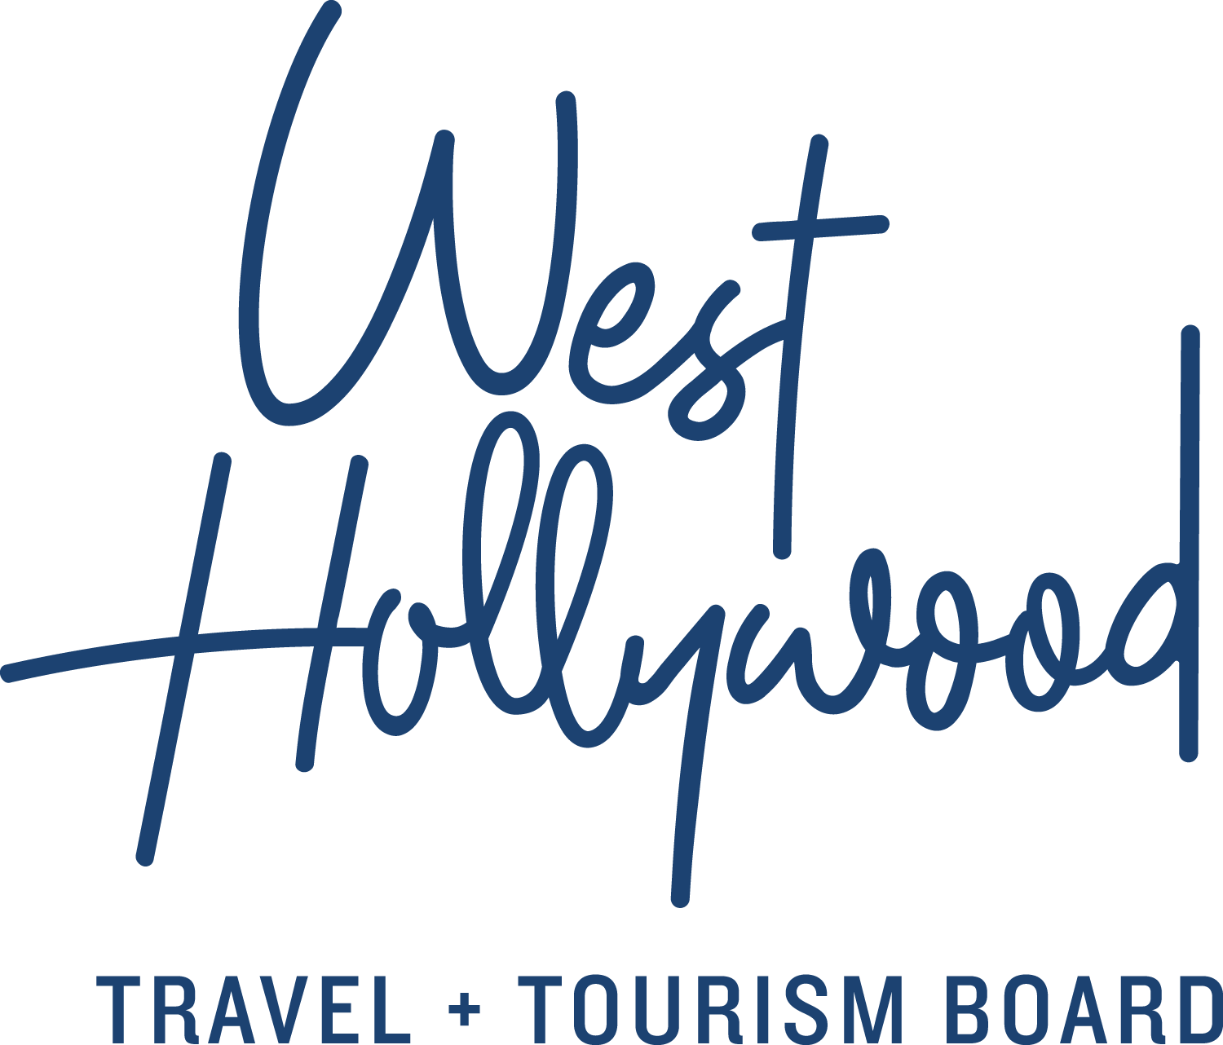
The 2018 State of the Hotelscape in West Hollywood, California
From renovations and rebranding to brand new hotels in 2018.

West Hollywood, California is a small city, only 1.9 miles square, in fact, getting a mini facelift in 2018. The hotel scene in West Hollywood is benefiting from some serious makeovers, with deeper than skin-deep renovations and killer amenities, while new 2018 hotel product increased the city’s inventory by almost 20%.

La Peer Hotel
You are now free to walk about the neighborhood, preferably from the indulgent digs of La Peer Hotel, a Kimpton property, which opened mid-January in the heart of West Hollywood’s lively Design District. La Peer signals “unbuttoned luxury” with its chic European-styled rooms, complete with white oak herringbone floors, a calming color palette and deep soaking tubs. It’s an intimate place, with just 105 guestrooms and suites, and a pool that’s refreshingly casual – accented with Gaudi tiles, shady olive trees and a RETNA mural wall.

Thoughtful amenities (such as Jade Yoga Mats in every room), services (like locally-renowned resident trainer Marco Reed overseeing on-site fitness classes and diet and meal planning as requested) and exclusive partnerships (with some of West Hollywood’s very best Bikes and Hikes LA) are par for the course here. Guests can expect room service reimagined with custom picnic baskets, a complete bath menu with butler service, and In Room Bottle Service for craft cocktails.

Step out the front door for exclusive shopping of cutting-edge clothing, eclectic art and forward-thinking design. Set your alarm for the highly anticipated modern trattoria, Viale Dei Romani, a signature dining concept created by Chef Casey Lane with a courtyard bar and an emphasis on wood-fired seafood, vegetables and handmade pastas.

The London West Hollywood at Beverly Hills
Just what does an $11 million refresh buy these days? Turns out to be a great deal at The London West Hollywood. Diamonds and blue sapphires may be the traditional gift to celebrate a tenth anniversary, but The London takes its cues from English country houses, where the bar reigns supreme. The ornate all-day meeting place is graced with natural light, marble and leather while it spills into the Boxwood restaurant, equally suitable for intimate dining and private functions.

The renovated rooftop pool and deck resembles an English garden (albeit one with palm trees and a saltwater pool). While the designers did not tinker with the staggeringly beautiful and panoramic views of the Hollywood Hills, they did add a soothing fountain and cabanas. What a way to enhance and pay homage to your best features.
Montrose West Hollywood
File under what’s old is very new again. Formerly known as Le Montrose Suite Hotel, the Montrose West Hollywood reveals its renovation and rebranding in July 2018. The 133 expansive suites and public spaces will celebrate Hollywood’s past and present music industry while incorporating eclectic furniture, lighting and art pieces that provide a memorable, distinctive design with residential scale. Designed by Perkins+Will, Montrose West Hollywood will feature a new upscale urban vibe, inspiring artists and entertainers seeking a place that feels like home. Being located on a quiet tree-lined street sure helps. With its coworking spaces, stylish lounging areas, a grab-and-go cafe and “Urban Apron” kits (influenced by the popular recipe delivery services), the Montrose market is aimed squarely at creatives, collaborators and millennials. For those with time, an overhauled three-meal-a-day restaurant will provide a contemporary menu from Michelin-rated Chef Bryan Achay.

The Chamberlain West Hollywood
Within a stone’s throw of Sunset and Santa Monica Boulevards, The Chamberlain’s redesign and new signature restaurant comes online in May 2018, and it’s shaping up to be another gem in the portfolio of OLS Hotels & Resorts. Re-imagined as a stylish retreat for A-list insiders, the hotel’s new design will feature sophisticated interiors reflective of old Hollywood glamour while appealing to the up-and-coming starlet. Designed by Perkins+Will, The Chamberlain West Hollywood’s new lobby and 115 spacious suites will feel like a chic home away from home with monochromatic tones, carefully curated art pieces, and luxe velvet and leather furniture. The contemporary and intimate eatery and bar, overseen by Executive Chef Henry Tapia, will serve New American cuisine. Tastemakers are sure to flock to a garden patio with a fire pit and trellis.

The Jeremy West Hollywood
Over the course of 2018, the 286-room Jeremy West Hollywood will transform into the 1 West Hollywood (www.1hotels.com) and become the fourth property in the award-winning eco conscious luxury sustainable brand created by Starwood Capital.

Upcoming hotel projects include the West Hollywood EDITION hotel, combining the intimate and personal experiences hotelier Ian Schrager is known for with the global expertise and scale of Marriott Corporation and a West Hollywood Pendry Hotel —a new luxury hospitality brand from Montage International, opening in late 2018 and 2019 respectively.

In some parts of the world cranes fly south for the winter. In West Hollywood, the beating pulse of Los Angeles, cranes signify forthcoming flights of verticality. So get horizontal at the intimate La Peer, give day drinking your best shot at The Boxwood at the London West Hollywood at Beverly Hills, get your creative on at the Montrose and mark your calendar for a date with updated Hollywood glamour at The Chamberlain. All substance, no fillers necessary.

About West Hollywood Travel + Tourism Board
West Hollywood Travel + Tourism Board is the official marketing organization that invites visitors to West Hollywood, California, a walkable, 1.9 square mile/4.9 square kilometer city in the heart of Los Angeles. Located at the base of the Hollywood Hills and adjacent to Beverly Hills, West Hollywood is a creative and progressive city that embodies the quintessential L.A. lifestyle. West Hollywood is home to 17 hotels and comprised of three main districts: the world-famous Sunset Strip with unparalleled nightlife, eclectic and LGBTQ-friendly Santa Monica Boulevard, and the Design District known for its sought-after shopping and dining. West Hollywood enjoys a year-round moderate climate and thanks to its prime location and hip atmosphere, West Hollywood serves as home and playground to many celebrities. Follow us on Facebook & Twitter (@westhollywood) and Instagram (@visitweho). www.visitwesthollywood.com
##
Press Contact:
Anne Van Gorp, media@visitwesthollywood.com

