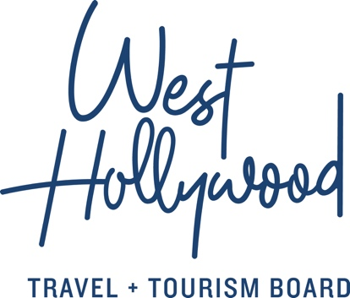

West Hollywood Travel + Tourism Board Presents Deadline Hollywood’s LGBTQ-Focused Podcast at Sundance Film Festival
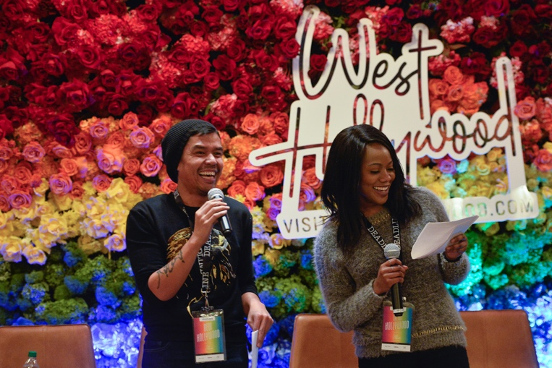
NEW HOLLYWOOD Podcast Moderators Dino-Ray Ramos and Amanda N’Duka
WEST HOLLYWOOD, CA (January 28, 2019) – In support of the creative and diverse voices in the Hollywood industry, West Hollywood Travel + Tourism Board (WHTTB) proudly presented Deadline Hollywood’s live extension of their NEW HOLLYWOOD podcast “LGBTQ Entertainers in Hollywood” on January 26 at Hotel Park City during the 2019 Sundance Film Festival in Park City, Utah.
“We are thrilled to be associated with Deadline’s NEW HOLLYWOOD podcast and live event series at Sundance. Our city is all about diversity, inclusion and creative expression – so this series is perfectly aligned with what we stand for - and why people from around the world want to come visit,” says Jeff Morris, CMO of WHTTB. “Our goal is to use this series as an invitation to everyone associated with Sundance to come visit our ‘Creative City’ in the heart of L.A.”

Moderated by Amanda N’Duka and Dino-Ray Ramos, panels titled “Bury Your Gaze: Subverting Queer Tropes in Film” and “Preserving the Past for the Future: Documenting Untold Histories” were recorded live in front of a captivated 100 person audience of filmmakers, industry leaders and enthusiasts. Panelists included Ryhs Ernst, Bobbi Salvör Menuez, Samantha Buck, Marie Schlingmann, Matt Tyrnauer and Patrisse Cullors.

”We could not think of a better partner than the West Hollywood Travel + Tourism Board, a city known throughout the world for its rich LGBTQ history, diversity and overall inclusiveness,” says Stacey Farish, General Manager/CRO of Deadline. “Many of West Hollywood’s residents and businesses have close ties with the entertainment industry, so this is really a perfect fit.”

Listen to the NEW HOLLYWOOD podcasts presented by the West Hollywood Travel + Tourism Board airing this week here: https://itunes.apple.com/us/podcast/new-hollywood/id1174096753?mt=2
About West Hollywood Travel + Tourism Board
West Hollywood Travel + Tourism Board is the official marketing organization that invites visitors to West Hollywood, California, a walkable, 1.9 square mile city in the heart of Los Angeles. Located at the base of the Hollywood Hills and adjacent to Beverly Hills, West Hollywood is a creative and progressive city that embodies the quintessential L.A. lifestyle. West Hollywood is home to 18 hotels and comprised of three main districts: the world famous Sunset Strip with unparalleled nightlife, eclectic and LGBTQ-friendly Santa Monica Boulevard, and the Design District known for its sought-after shopping and dining. West Hollywood enjoys a year-round moderate climate and thanks to its prime location and hip atmosphere, West Hollywood serves as home and playground to many celebrities. Follow us on Facebook & Twitter (@westhollywood) and Instagram (@visitweho). www.visitwesthollywood.com

About Deadline Hollywood
With nearly 15 million monthly unique visitors, Deadline Hollywood (Deadline.com) is the preeminent source of entertainment news and the leading information destination for the industry’s biggest decision-makers every day. When news happens; Deadline gets it first, gets it fast and gets it right. Rigorous reporting, relevance and reliability make Deadline the most read and influential entertainment news outlet among all key industry players.

##

Media Contact:
Anne Van Gorp
Director of Communications, West Hollywood Travel + Tourism Board
media@visitwesthollywood.com, 310-289-2525

